Prosody in Dialog Assessment Checklist Subject, Dialog segment:
Rater, Date:
Constructions and Functions

Turn Management
Turn take
Turn yield
Filled pause
Turn holding
Backchannel response
Backchannel cue
Supportive overlap
Particle-assisted turn switch

Topic Management
Topic starting/continuation
Topic closing
Topic development
Off-topic-contribution
Expressing Stance
Positive assessment
Seeking empathy/agreement
Expression of indifference

Marking Information Structure
Important
Parenthetical
Rhetorical pause
Contrast

Performing Speech Acts
Suggesting
Cueing immediate action

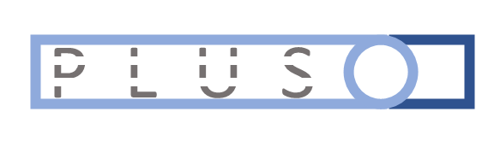
Features
low pitch high pitch
monotone pitch excursions
vibrato syllable stresses
quiet loud
reduced precise articulation
slow fast
creaky breathy
nasal harmonic

version 1.2.1, November 1, 2020, Nigel G. Ward

Purpose
This checklist is designed to support the assessment of an individual’s prosodic skills, either overall or regarding specific areas or specific skills. It has been piloted on typical speakers, autistic speakers, and non-native speakers.
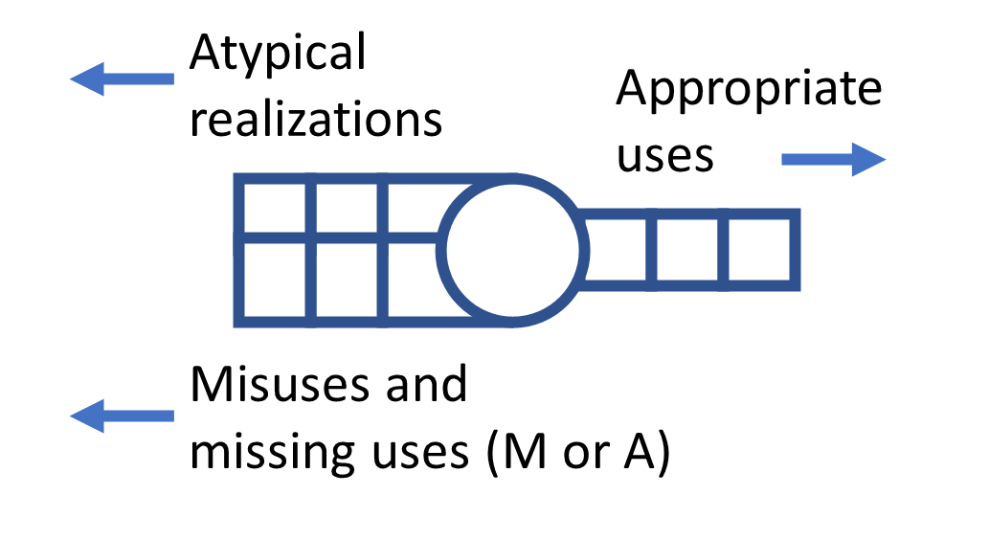
Use
Listen first once to the dialog, then again, focusing on the behavior of the target individual, and noting salient prosodic happenings. For each, identify the relevant factor, then mark the approprate square(s) in the checkbox cluster(s). A single prosodic happening may involve multiple functions or features. Pausing and replaying may be needed
Regarding the functional uses of prosody, use the short left checkboxes for cases where the intent is clear and the use appropriate, but aspects of the realization are unusual to the point of possibly interfering with the interlocutor’s ability to understand the intent, but not for insignificant dialect or idiolect differences. Use A to mark a salient Absence of the appropriate prosody and M to mark a Misuse of the prosodic form.
Regarding feature use, use P if that feature is present pervasively, L largely lacking, U if its appearance seems to be sometimes uncontrolled, and S it it seems to be used in some systemtic, but non-standard, way. If it seems to be used correctly, check the rightmost box.
Finally, after listening to the dialog, review all items. At this time it’s often possible to name notes regarding feature use, based on overall impressions.
Since the checkbox clusters are designed for recording mostly production skills, observations regarding interpretation skills should be recorded on the side. For example, responses that indicate successful
interpretation of some meaning conveyed by the interlocutor’s prosody can be indicated with △ , and
salient failures to pick up on some prosodic meaning with ✕ .
Other issues should be recorded as freeform notes. These may include overreliance on one or a few prosodic patterns, prosody that gives an unfortunate impression --- such as of aggression, annoyance, or timidity --- and unclear cases.
Preparation
Before using the checklist, ideally study the descriptions in Chapters 1-8 and 11-14 of Prosodic Patterns in English Conversation (Nigel G. Ward, Cambridge University Press, 2019). The skill names in the checklist are mnemonics for specific constructions, each with a specific family of functions, and a specific typical prosodic realization, as described in the book and illustrated with audio examples at http://www.cs.utep.edu/nigel/english-prosody/ .
Limitations
The list of skills is derived from those presented in the book, which was developed from an analysis of conversations among 12 university students speaking American English in El Paso, Texas. This list includes constructions explaining 44% of the variance in the computed prosodic features, but is not exhaustive. The reliability, validity, and utility of the checklist have not yet been assessed.

